For a growing number of grandparents, the golden years are beginning to resemble a time of increased responsibilities, especially when it comes to caring for young children. Grandparents may be facing health problems, limited income, and decreased mobility, but instead of planning for their retirement, they're planning for a child's college expenses. A new phrase has been created for this child care phenomena, the 'skipped-generation' household, where a grandparent and grandchild reside with no parent present.
According to the 2000 U.S. Census Bureau findings:  - More than 5.8 million children are being raised in households headed by grandparents and other relatives.  - 2.5 million children are in grandparent-headed households without any parents present.  - 2.4 million grandparents report they are responsible for their grandchildren living with them: 29% of these grandparents are African American; 17% are Hispanic/Latino; 2% are American Indian or Alaskan Native; 3% are Asian; 47% are White.  - 71% of these grandparents are under the age of 60.  - 19% of these grandparents live in poverty. | 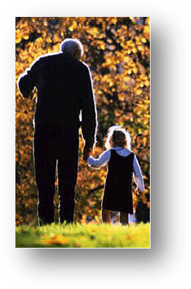
According to the 2000 U.S. Census Bureau report for Florida:
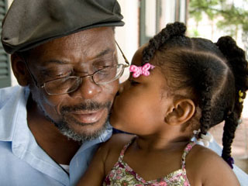 | - 258,952 children live in grandparent-headed households (7.1% of all the children in the state). There are another 86,152 children living in households headed by other relatives (2.4% of all the children in the state). Of the children living in households headed by grandparents or other relatives in Florida, 151,492 are living there without either parent present.  - 147,893 grandparents report they are responsible for their grandchildren living with them.
- 35% of these grandparents live in households without the children’s parents present.
- 69% of these grandparents are under the age of 60.
- 18% live in poverty.

Keeping your Grandchildren Safe from Medications

Prescription medication for the elderly are some of the most toxic and therefore present the greatest potential for tragedy if accidentally ingested by children. Not everybody thinks about safeguarding their medicine when young children are around. A study conducted by the United States Consumer Product Safety Commission states that 36 percent of childhood ingestion accidents related to prescriptions involve a grandparent’s medication. Even the most careful and loving grandparent can put their grandchildren in danger when they unknowingly overlook simple precautions. It is more important than ever that the guidelines listed on the back of this page are followed:

- When visiting a home with young children, make sure medications in purses, bathroom kits, and suitcases are not available to children.  - Be careful of weekly pill minders. They help to organize medication but most are not child resistant.  - If young children visit your home, remember to keep medications and household chemicals locked or out of children’s reach.  - Avoid taking medication in front of young children, they like to imitate.  - Only give infants and children over-the-counter medications that are specially formulated for their age and weight. | 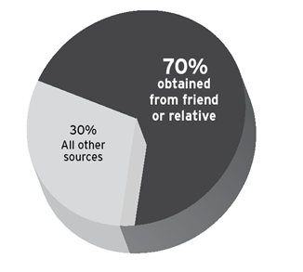Almost 70% of prescription drugs accidentally ingested by children are obtained from a friend or relative

State and National Resources for Skipped-Generation Households
FLORIDA
Florida GrandsPlace - http://www.grandsplace.org/gp4/fl.html
Florida Kinship Center - http://www.flkin.org/statewidegroups.asp
Florida Grandparents Raising Grandchildren - http://groups.yahoo.com/group/FloridaGRG
NATIONAL
AARP Foundation Grandparent Information Center - www.aarp.org/grandparents
National Aging Information Center -http://www.aoa.gov/prof/notes/notes_grandparents.asp

Consumer Product Safety Commission - http://www.cpsc.gov/cpscpub/pubs/grand/704.html
The Grandparent Foundation - http://www.grandparenting.org/
National Center on Grandparents Raising Grandchildren - http://chhs.gsu.edu/nationalcenter
National Committee of Grandparents for Children’s Rights - http://www.grandparentsforchildren.org/
National Capital Poison Center - http://www.poison.org/

