
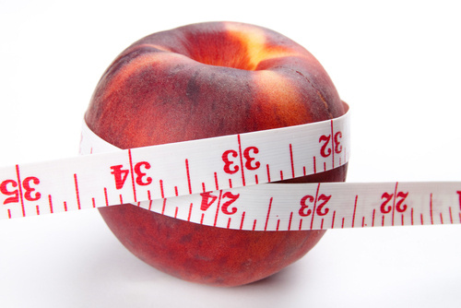
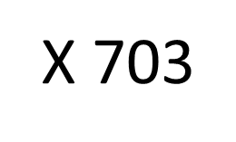

What is BMI?

FSU College of Medicine
1115 W. Call St
Tallahassee, FL 32304

BMI, Osteoporosis, and Food Safety

Nutrition
Florida State University College of Medicine
Body Mass Index (BMI) is a number calculated from a person's weight and height.
BMI provides a reliable indicator of body fatness for most people and is used to screen for weight categories that may lead to health problems.

BMI = Weight (pounds)
_____________
[Height (inches)]²
Calculating BMI

Understanding BMI

Osteoporosis
BMI is an estimate of body fat and a good gauge of your risk for diseases that can occur with more body fat.
The higher your BMI, the higher your risk for certain diseases such as heart disease, high blood pressure, type 2 diabetes, gallstones, breathing problems, and certain cancers.
Although BMI can be used for most men and women, it does have some limits:
- It may overestimate body fat in athletes and others who have a muscular build.
- It may underestimate body fat in older persons and others who have lost muscle.
BMI | Result
Below 18.5 | Underweight
18.5-24.9 | Healthy
25 – 29.9 | Overweight
30 and Above | Obese

What?
Osteoporosis is a bone characterized by low bone density. It often results in fragile bones and increased risk for hip and back fractures. It can often have no symptoms until there is a fracture.
Who?
If you are…
-have a family history of osteoporosis or bone fracture/fragility
-older age
-low BMI (less than 20)
-use tobacco
-have kidney stone disease
…you should get tested.
Prevention
Weight Bearing Exercise
-walking, hiking, jogging, dancing, lifting weights, etc.
Vitamin D Supplements
-no more than 800 IU/day
Calcium- 1500 mg/day
-orange juice, cheese, milk, yogurt

Food Safety
Risky Foods
-Meats, seafood, or poultry that are raw or undercooked
-Unpasteurized dairy products or juices
-Hot dogs, cold-cuts, and dry or fermented sausage if not reheated

Tips
-Wash hands for 20 seconds with warm soapy water before and after meal preparation
-Keep a thermometer handy
-meats-180°F
-other meats, eggs, and casseroles- 160°F
-ALL foods should be reheated to 165°F
-Check the refrigerator and freezer at the beginning of every week and discard expired items
-Use a separate area for meat and vegetables when cooking, and be sure to sanitize both areas when done
These tips and more at
http://www.caring.com/articles/elderly-food-safety-10-tips-guidelines-for-the-elderly

