DropBox

1. Go to: <https://dropbox.fsu.edu>
2. Select “Drop-off”:

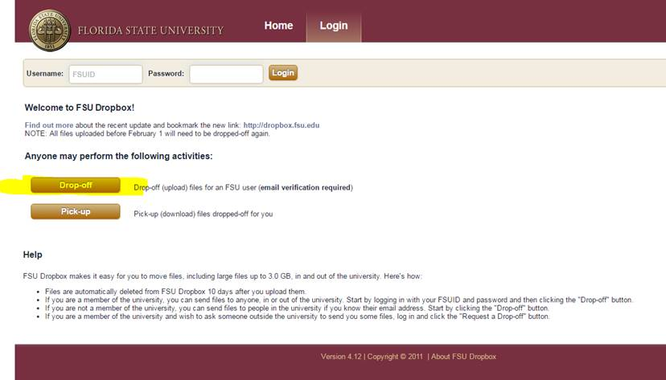

1. Fill out your information:

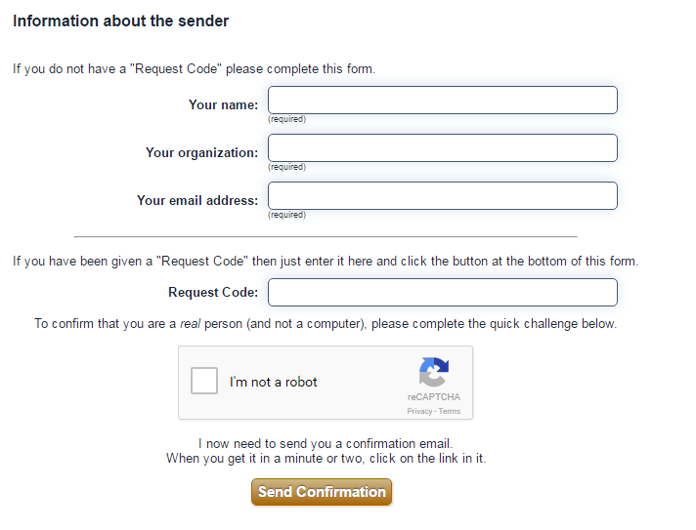

1. It will send you a confirmation email.  Click on it, and it should redirect you back to DropBox’s website.

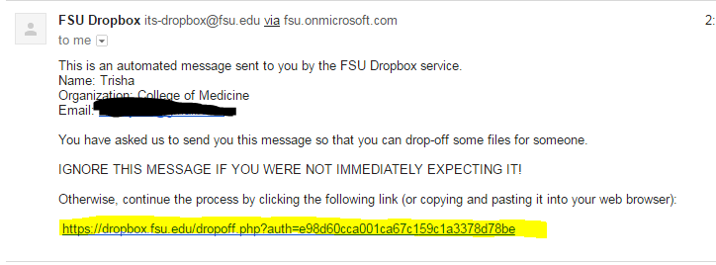

1. Once back at DropBox, you’ll fill out the below information and upload your documents.  Please make sure to use the email information below this screenshot. You can choose the documents you want to attach. When done, click “Drop-off Files”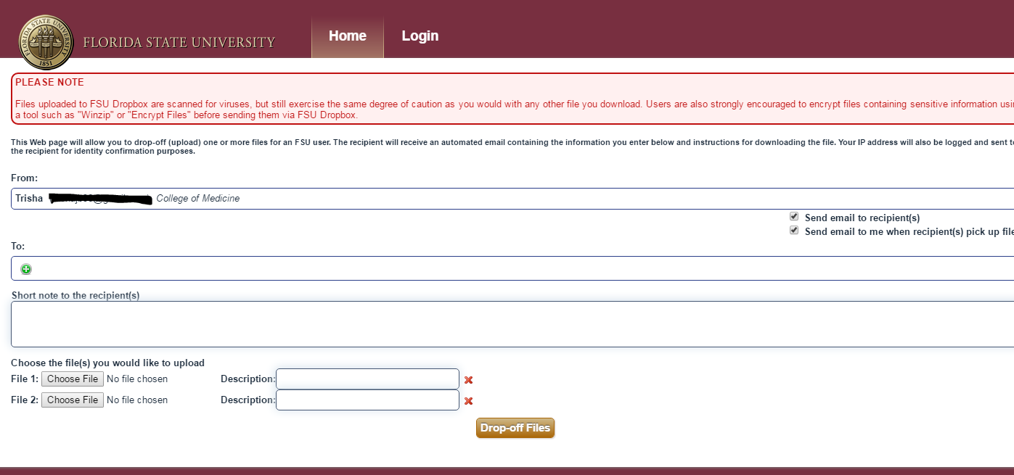

Email Info:

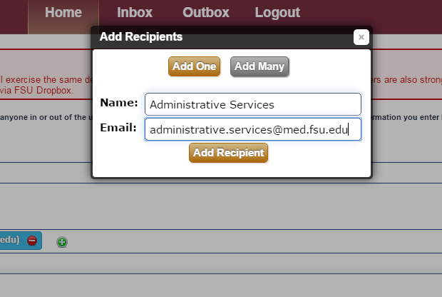

Please someone from Admin Services know if you have any issues. Feel free to follow-up with us once you send us your documents.